Google Bling

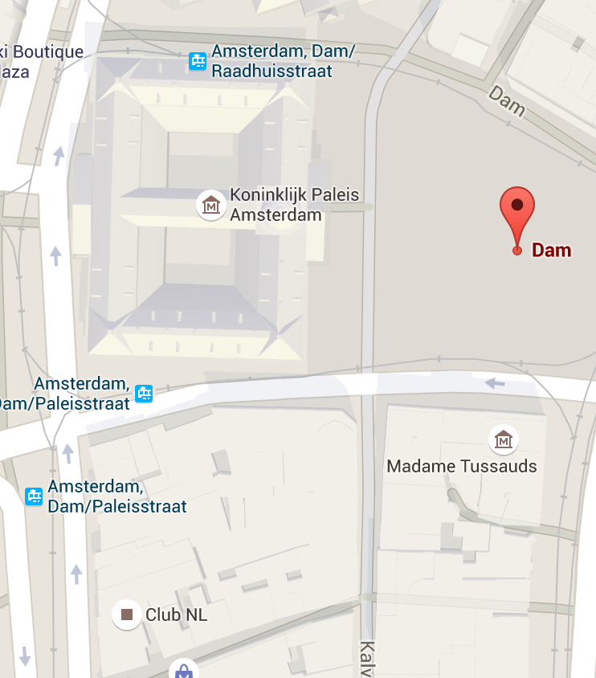 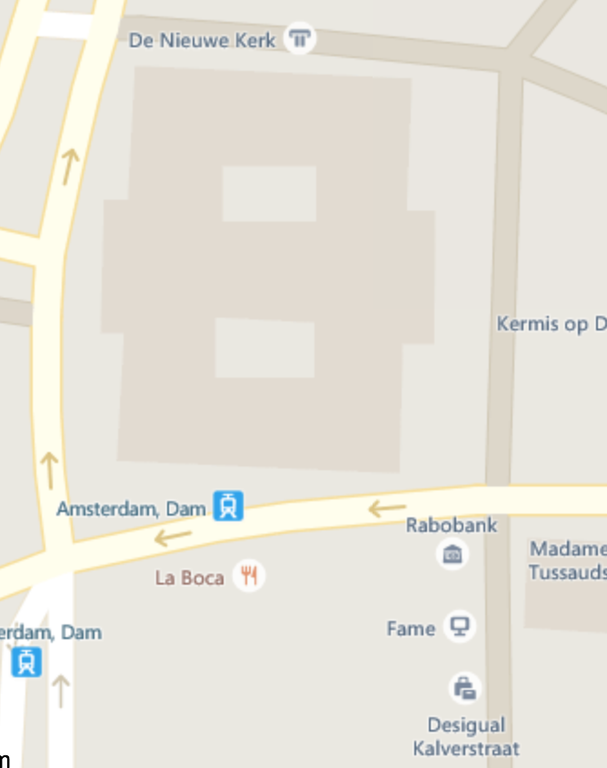

1.1 As you can see in these both visualizations of the map of ‘de Dam’ in Amsterdam, there is actually a big difference between Google and Bling. The first difference of the visualization of the buildings is that the ‘Koninklijk Paleis’ is visualized much more detailed in Google’s than in Bling’s map. Furthermore, Bling does not show the regular houses. Conclusion: Google promotes an easier visual search for buildings

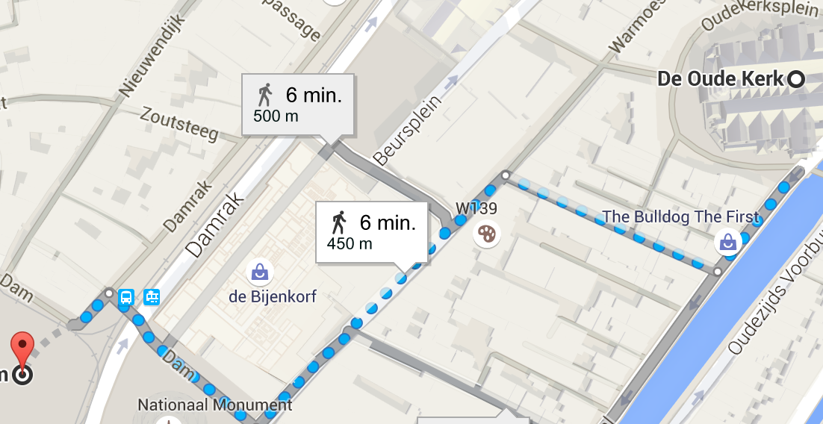 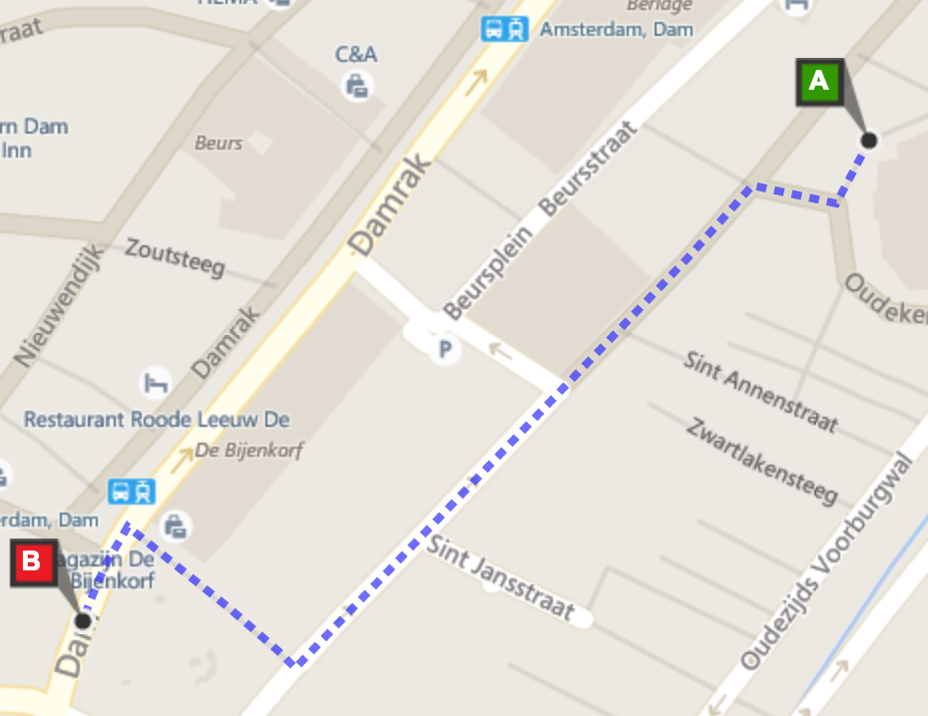

1.2 The visualisation of all the buildings in Google makes the visualization of the route between two places less clear than in Bling. The grey areas in Bling, which denote buildings, make a bigger contrast between the blue route than in Google’s map.

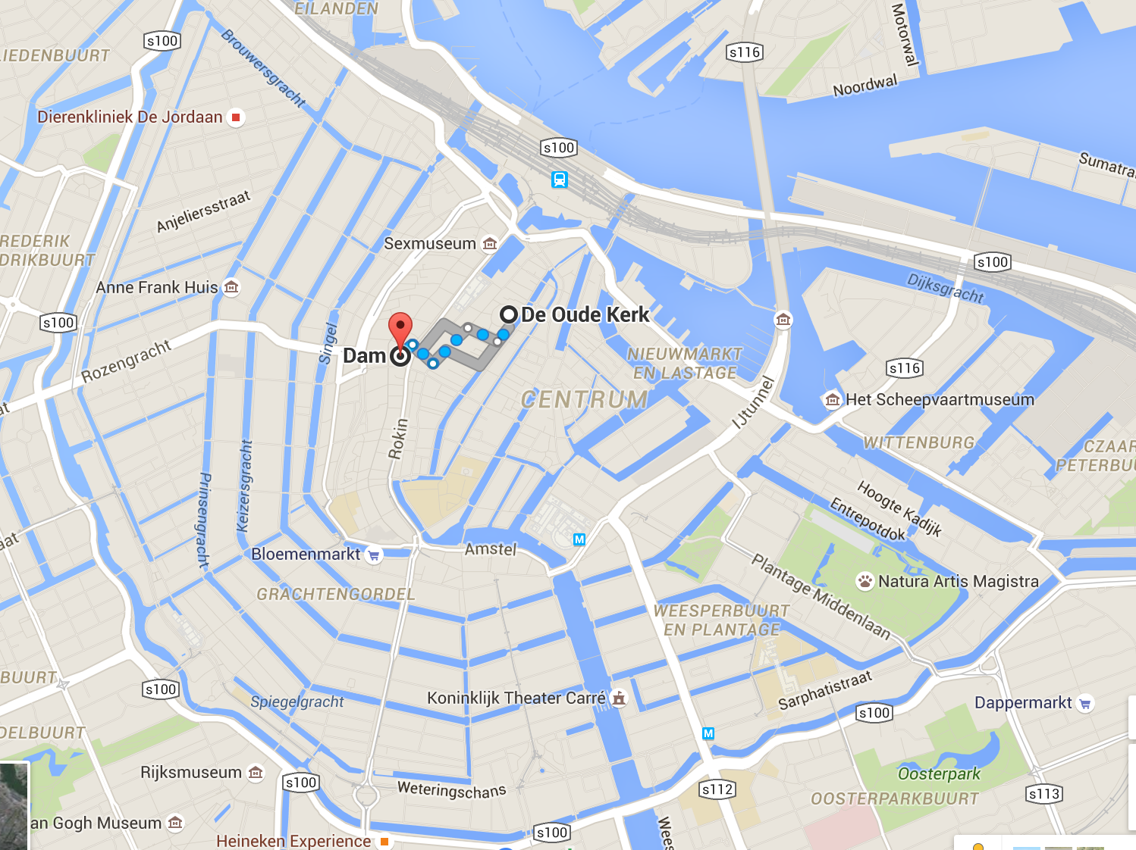 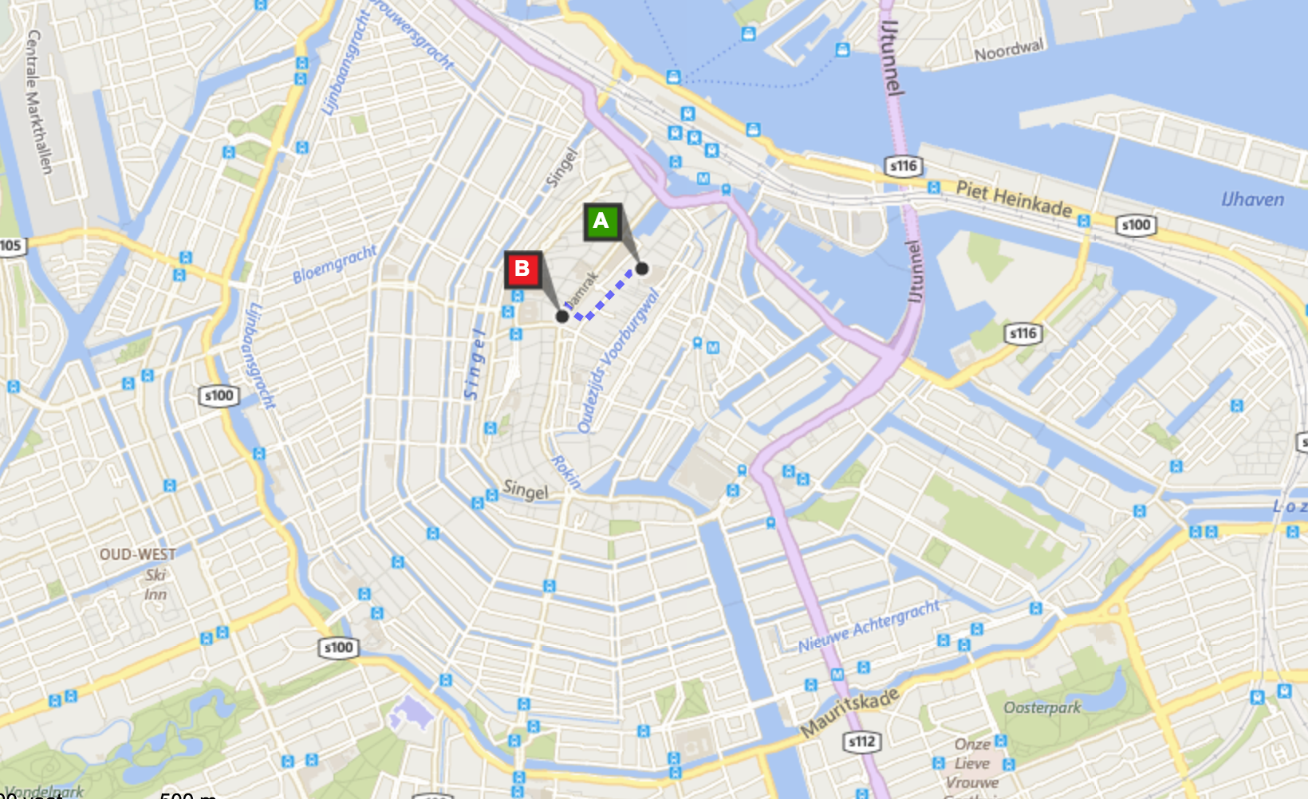

1.3 There is actually no best visualisation. It depends on the purpose of the map you want to use it for. The Google map has a much more fancy outlook than the Bling map. When zooming in, the map shows the shape of the buildings which is a very nice tool. When you want to use the map to find a route, the Bling map is a better option. As you can see in the right picture, the Bing map visualises different colours for different kind of streets. Besides that, because of not showing the buildings in detail, when one zooms in, the roads are much more clear. That’s because this leads to a higher contrast between the roads and environment.

2.1

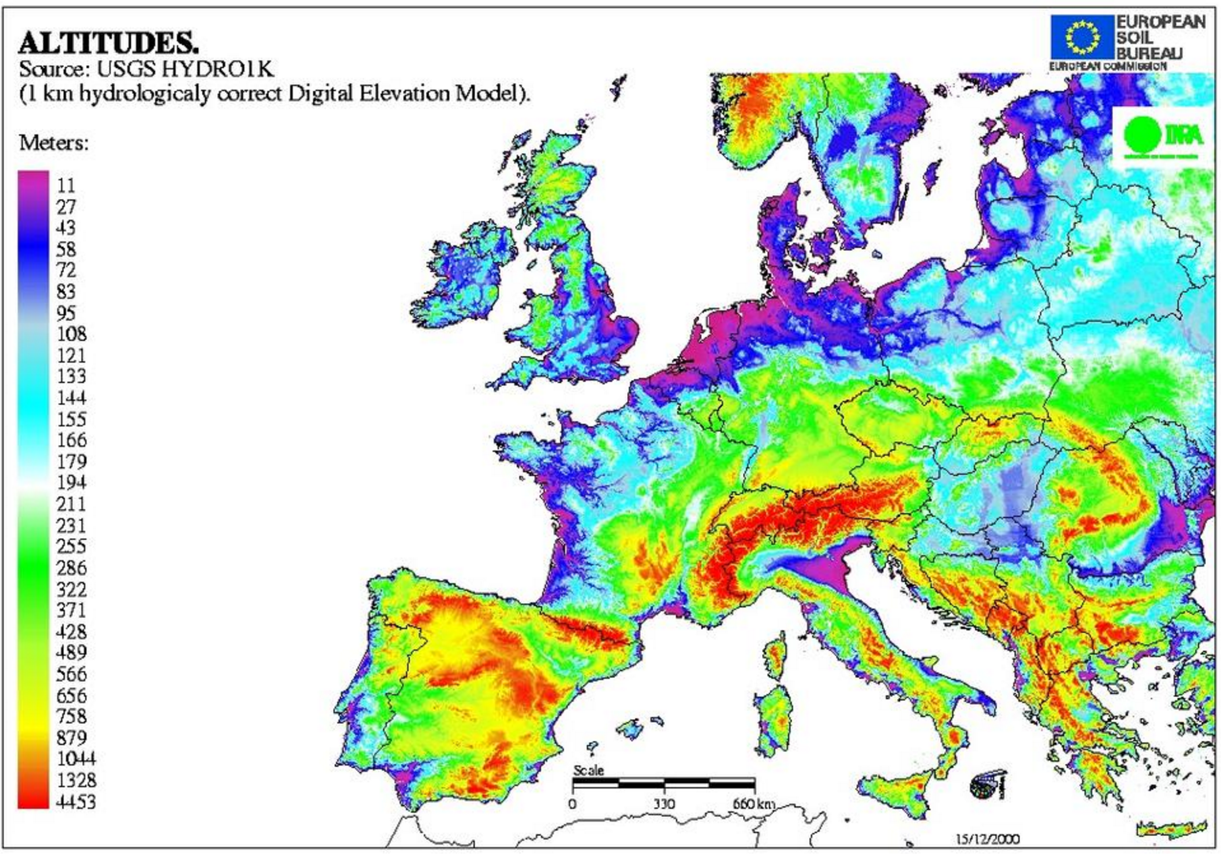

In this visualization the altitude in Europe is shown as a rainbow colour map. The designer of this map wants to show the audience a clear view on the altitude differences in Europe. He wants to reach this goal with a rainbow colour map. But is that the right way to reach it? In my opinion it is not. The colour purple does have a little contrast with red, while both colours are representing completely different data. You could interpret purple areas as being of a higher value than the red one.

2.2 To avoid this misunderstanding one could take only a part of the rainbow colour palette, for example only the bottom half of the spectrum of the map. So green should be the lowest height and red the highest one. This would give a much better overview of altitudes in Europe. A side effect is that there is less distinction of altitude on local scale.